**RAIN ALARM**

PDC Project Report

Submitted in Partial Fulfilment of the Requirements

For the award of the Degree of

**Bachelor of Technology**

**In**

**Electronics & Computer Engineering (ECM)**

By

**B.Ankitha(19311A1956)**

**T.Rohit(19311A1957)**

**G.Raveena(19311A1958)**

Under the guidance of

**K. ARUNA KUMARI**

**Asst.Professor, ECM**

#### 

**Department of Electronics & Computer Engineering**

**Sreenidhi Institute of Science & Technology (Autonomous)**

**April - 2022**

**DEPARTMENT OF ELECTRONICS & COMPUTER ENGINEERING**

**SREENIDHI INSTITUTE OF SCIENCE & TECHNOLOGY (AUTONOMOUS)**



**CERTIFICATE**

This is to certify that the PDC Project work entitled “RAIN ALARM”, submitted by **B.ANKITHA (19311A1956), T.ROHIT (19311A1957), G.RAVEENA (19311A1958)** towards partial fulfilment for the award of Bachelor’s Degree in Electronics & Computer Engineering from Sreenidhi Institute of Science & Technology, Ghatkesar, Hyderabad, is a record of bonafide work done by them. The results embodied in the work are not submitted to any other University or Institute for award of any degree or diploma.

**(Lab Project Coordinator-1) (Lab Project Coordinator-2)**

**K.ARUNA KUMARI D.Ramya Vani Dr. D. Mohan**

**Asst.Professor,ECM Asst.Professor,ECM HOD,ECM**

**ACKNOWLEDGMENT**

We owe a great many thanks to a great many people who have helped and supported us throughout this project, which would not have taken shape without their co-operation. Thanks to all.

We express our profound gratitude to **Dr.T.Ch. Siva Reddy, Principal** and indebtedness to our management Sreenidhi Institute of Science and Technology, Ghatkesar for their constructive criticism.

We would like to specially thank our beloved **Head of Department, ECM,**

**Dr. D. Mohan,** for his guidance, inspiration and constant encouragement throughout this research work.

We would like to express our deep gratitude **K. Aruna Kumari, Asst Professor (Project Coordinator)**, for her timely guidance, moral support and personal supervision throughout the project.

These few words would never be complete if we were not to mention our thanks to our parents, Department laboratory, staff members and all friends without whose co-operation this project could not have become a reality.

**B.ANKITHA (19311A1956)**

**t.ROHIT (19311A1957)**

**G.RAVEENA (19311A1958)**

**ABSTRACT**

Rain Alarm Project is a simple but very useful project that detects Rain(Rain Water) and automatically triggers an alarm or buzzer

Water is a basic need in everyone’s life. Saving water and proper usage of water is very important. Here is an easy project which will give the alarm when there is rain, so that we can make some actions for rain water harvesting and also save the rain water for using it later.

With the help of saving water through rain water harvesting, we can increase the levels of underground water by using underground recharge technique.

Rain Water detector will detect the rain and make an alert, rain water detector is used in the irrigation field, home automation, communication, automobiles etc. Here is the simple and reliable circuit of rain water detector which can be constructed at low cost.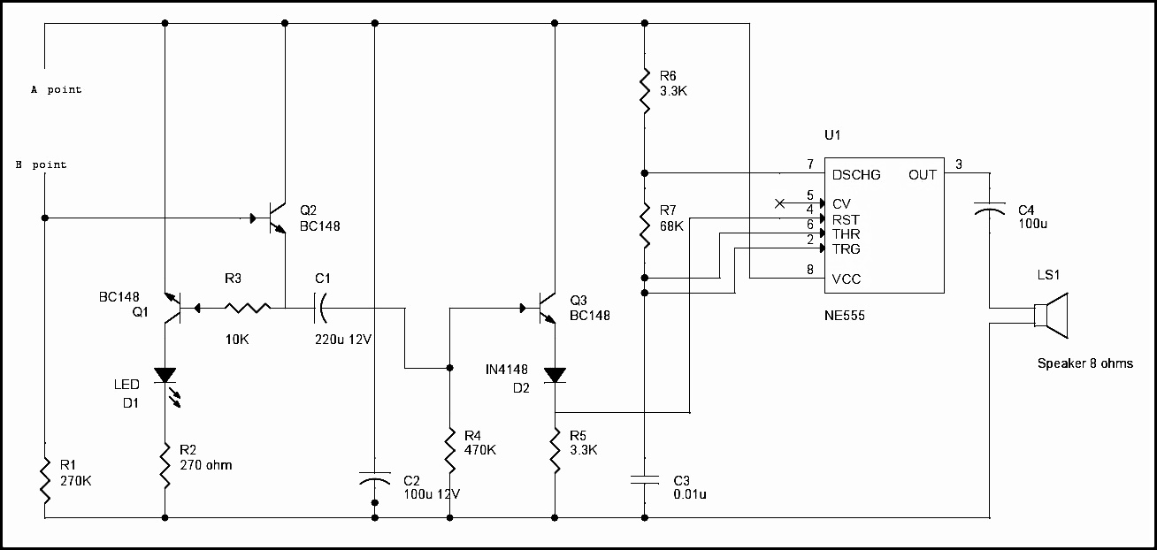

**CONTENTS**

**Abstract i**

**Contents ii**

**List of Figures iii**

**1. Introduction 01**

1.1 Circuit description **01**

1.1.1 Block Diagram **01**

1.2 Circuit operation **01**

**2. Hardware requirements 02**

2.1 Components **02**

**3. Circuit diagram 03**

**3.1 Circuit Diagram of Rain Alarm Using 555 TIMER IC**  **03**

**3.2 Working of the circuit 04**

**4. Applications 05**

4.1 Advantages **05**

4.2 Disadvantages  **05 5.Conclusion 06**

**References 07**

**LIST OF FIGURES**

Figure 1.1.1 : Block diagram of rain alarm 01

Figure 2.1.1 : Soldering rod 04

Figure 2.1.2 : Speaker(8ohm 0.5watt) 04

Figure 2.1.3 : Battery(9v) 04

Figure 2.1.4 : Transistor(BC 548) 04

Figure 2.1.5 : Resistor(47K) 04

Figure 2.1.6 : Resistor(4.7k) 04

Figure 2.1.7 : Resistor(1k) 04

Figure 2.1.8 : Capacitor(100uf 16v) 04

Figure 2.1.9 : Diode(IN4148) 04

Figure 2.1.10: IC 555 04

Figure 2.1.11: Capacitor(0.01uf) 04

Figure 2.1.12: voltage regulator(100k) 04

Figure 2.1.13: IC astable multivibrator 04

Figure 2.1.14: IC block diagram 04

Figure 3.1.1: Fire alarm circuit diagram 05

Figure 4.1 : Fire alarm output 08

**CHAPTER 1  
INTRODUCTION**

* 1. **CIRCUIT DESCRIPTION**

Rain Alarm Circuit consists of three main components that include **Rain sensor, 555 Timer IC** and a**buzzer**. The heart of rain alarm circuit is rain sensor which is used to detect the presence of water.

**1.1.1 DESIGN**

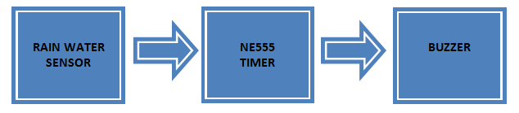

* 1. **CIRCUIT OPERATION**

When there is no rain, the resistance between the wires of rain sensor will be very high and there will be no conduction between the wires on sensor.

When the rain drop falls on the sensor, it will form a conductive path between the wires and the resistance between wires will decreases. At this point, the wires on sensor board will start conducting current.

Simply, this sensor is working as a switch, so whenever water is present on the sensor it allow the current to pass through it (ON condition). And, if there is no water then it discontinues the flow of current (OFF condition).

**Chapter 2**

**Hardware Requirements**

**2.1 Components Required to for a rain alarm Circuit:**

* 555 Timer IC
* Rain Sensor
* Transistors- 1xBC548 , 2x 2N2222 NPN
* Capacitor- 1x22uf, 2x100uf
* Diode- 1xN4007 PN junction diode
* Ceramic capacitor- 1x10nf ,1×100 pf
* Resistors- 1×68 k Ohm, 2×3.3 k Ohm, 1×470 k Ohm, 1×10 k Ohm, 1×330 k Ohm, 1×220 k Ohm
* LED
* Connecting wires
* Breadboard
* 12 V power supply

**2.2 Rain Water Sensor:**

The Rain Water Sensor used in this project is shown in the image below. It is a simple sensor and it is an easy to use tool for detecting rain. It can act as a simple switch, where the switch is normally open and when there is rain, the switch closes.

Even though Rain Water sensor is the main component in the circuit. We need not to go and buy in the market or online. We can do it ourselves just by taking the piece of Bakelite or Mica board and aluminium wire. Bakelite or Mica board should be made completely flat and aluminium wire should be pasted on the flat board as shown in the figure below. Care should be taken that there should be no spaces between the wire and board.

When the rain water sensor is completed, it should get connected to the circuit and voltage should be passed through the wires.

If there is no rain, the resistance between the contacts will be very high as there will be no conduction between the wires in the sensor.

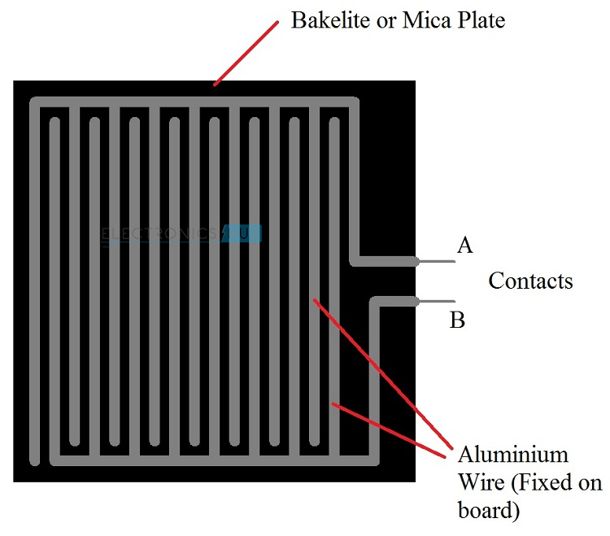

If there is rain, the water drops will fall on the rain sensor, which will form a conductive path between the wires and it also decreases the resistance between the contacts.

As a result, the wires on the sensor board will conduct and trigger the NE555 timer through the transistors circuitry. Once NE555 is triggered, it will make the output pin high and which will make the buzzer to make alarm.

**CHAPTER 3**

**CIRCUIT DIAGRAM**

**3.1.1 Circuit Diagram of Rain Alarm Using IC 555 Timer**:



**3.1.2 Working of the Circuit**:

The 555 timer IC is configured in A-stable mode. Here, the buzzer is connected with output of 555 Timer IC which means that when the output of 555 Timer is high the buzzer will turn ON and when the output of 555 Timer is low then buzzer will be turned OFF. You can also change the buzzer beep frequency using the above equation.When the rain drop falls on the sensor, the wires on sensor starts conducting and closes the path between supply and base of transistor Q2. Therefore, transistor Q1 and Q2 will turned ON, and by which the LED will also turn ON. When the transistor Q2 is saturated, C1 will get shorted and make the transistor Q3 turned ON. At this point C1 will get charged by the resistor R4. As the transistor Q3 reaches the saturation mode, the reset pin of 555 Timer IC will get positive. As soon as the reset pin of timer gets the positive voltage, we can get a pulse signal at the output pin of 555 Timer IC. This will turn on the buzzer and make the alarm beep. The capacitor is connected to pin3 of 555 Timer IC and speaker is for blocking the DC signal. And, due to diode D2, no reverse current will be allowed from the timer. ransistor Q3 will get into cut-off region after some time because of resistor R4 and capacitor C1.In result, there will be no positive voltage at reset pin of timer and buzzer will stop making sound. The sound of buzzer entirely depends on capacitor C1 and resistor R4.And, if there is no rain, the sensor will not allow the current to pass through it. In result the 555 Timer IC will not be triggered and the buzzer remain in off condition.

There are two things which must be kept in mind while using the circuit. Rain sensor should be kept at an angle of 30 to 40 degree from ground to avoid the presence of water on sensor for long time. Second thing is that the LED will keep glowing until the rain stops and the buzzer will stop making sound automatically after some time.

**CHAPTER 4**

**APPLICATIONS**

**Rain Alarm Circuit Applications**:

* In irrigation, it can sense rain and inform the farmers on time
* In household, the circuit can work to start other automated rain water harvesting machines to harvest rain
* In automobile, it can start the wiper and inform the driver in case of rain.
* It can be used to detect chemical rain also.
* It can be used to boost strength of antenna and increase the signal strength to send and receive signals.
* Helps you save electricity

**4.1 Rain Alarm Circuit Advantages:**

* It is very cheap
* The battery lasts for a good period of time
* It is not risky
* It has no harmful effect
* The circuit can be made by anyone with basic knowledge or guidance

**4.2 Rain Alarm Circuit disadvantages:**

* It doesn’t tell about the speed of the rain which is fallen on the roof.
* It will send signal or the led will be glowing until the detector becomes wet.
* It something is over that then the detector will not work until it gets wet.
* There are so many problem that you will face when you will make this circuit.

**CHAPTER 5**

**CONCLUSION**

In a world full of automation, everyone wants to stay smart and productive. And, water harvesting can also be achieved easily with the help of automation. Here in this article, we will be discussing the Rain Alarm project which has a great significance in harvesting rainwater. The circuit helps to detect the rain by giving an alarm while you are sitting inside the home, so that you can take necessary action. It totally helps in avoiding the unnecessary headache of keeping an eye outside your window in the rainy season to see when it is going to rain. To save your time money and effort let’s start with the process of making a simple and cost effective rain alarm circuit in the easiest way.

Rain Alarm circuit is very useful and easy to design. In this article, we have discussed the cost effective rain alarm circuit with its circuit diagram, block diagram, working and its various applications. We hope that you will be able to design this highly reliable Rain Alarm circuit with ease. We have also explained the working of main components in the circuit i.e. – 555 Timer IC and Rain sensor in brief, that will help you understand the Woking of circuit more clearly.

**REFERENCES**

* <https://www.circuiteasy.com/rain-alarm>
* <https://www.circuitstoday.com/rain-alarm-circuit>
* <http://www.idc-online.com/technical_references/pdfs/electronic_engineering/Rain%20Alarm%20Project.pdf>
* <https://how2electronics.com/rainfall-detector-alarm-using-555-timer/>
* <https://circuits-diy.com/how-to-make-rain-alarm-circuit-electronics-projects/>